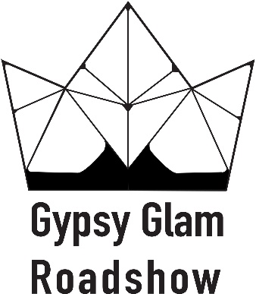

Corks & Chords
Contract for Food Trucks & Alcohol/Booze sales
Location: Bicentennial Park, 500 Couch Dr., OKC, OK
Date: Saturday, September 28, 2019
Time: 4pm-9pm
Move In: Saturday, September 28, 2019 at 12pm (noon)
Move Out: Saturday, September 28, 2019 at 9pm

Exhibitor Information
Contact Name: ________________________________ Email: ___________________________________________
Company Name: _____________________________________________________ (This is how your company name will appear)
Address: _______________________________________City: _________________________ State: _______ Zip ___________
Phone: __________________________________ Website/Facebook ______________________________________________
Products to be exhibited: __________________________________________________________________

Payment Information (We must receive your payment and contract to assign you a booth) MAKE CHECKS PAYABLE TO GG ROADSHOW. MUST BE HARD COPY MAILED.
____ Payment in full is enclosed. _____ $50
____ Check number (Returned check fee is $50.00)
Mail your contract along with your full payment to:
Gypsy Glam Roadshow
P.O. BOX 23882
Oklahoma City, OK 73123

Sign __________________________________________________ Date ________________

Cancellation Policy – There are no refunds. Cancellations must be submitted in writing.

