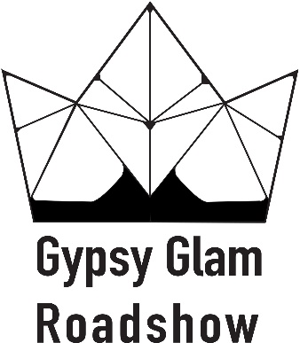

Fall Festival
Contract for Food Trucks
Location: Eldon Lyon Park, 7400 N.W. 36th St., Bethany, OK 73008
Date: Saturday, October 26, 2019
Time: 11am-3pm
Move In: Saturday, October 26, 2019 at 9am
Move Out: Saturday, October 26, 2019 at 3pm

Exhibitor Information
Contact Name: ________________________________ Email: ___________________________________________
Company Name: _____________________________________________________ (This is how your company name will appear)
Address: _______________________________________City: _________________________ State: _______ Zip ___________
Phone: __________________________________ Website/Facebook ______________________________________________
Products to be exhibited: __________________________________________________________________

Payment Information (We must receive your payment and contract to assign you a booth) MAKE CHECKS PAYABLE TO GG ROADSHOW. MUST BE HARD COPY MAILED.
____ Payment in full is enclosed. _____ $50
____ Check number (Returned check fee is $50.00)
Mail your contract along with your full payment to:
Gypsy Glam Roadshow
P.O. BOX 23882
Oklahoma City, OK 73123

Sign __________________________________________________ Date ________________

Cancellation Policy – There are no refunds. Cancellations must be submitted in writing.

